|  |  |
| --- | --- |
| **NIPPER BOARD**  **ORDER FORM** | |
| NAME: |  |
| SURF CLUB/ORG: |  |
| MOBILE: |  |
| EMAIL: |  |
| DELIVERY ADDRESS: | STREET:  SUBURB:  STATE:  COUNTRY: |
| DELIVERY INSTRUCTIONS: |  |

|  |  |  |  |
| --- | --- | --- | --- |
| **INDIVIDUAL DETAILS** | | | |
| GENDER: |  | AGE: |  |
| WEIGHT (KG): |  | HEIGHT (KG):: |  |

|  |  |  |
| --- | --- | --- |
| **BOARD DETAILS** | | |
| TYPE OF BOARD: | ***NIPPER BOARD*** | QTY REQD: |
| BOARD WEIGHT/SIZE: | _____ KG | CONFIRMED WEIGHT/SIZE:   _____ KG |
| MAKE | CARBON EPOXY | |
| MODEL/DESIGN | CUSTOM STOCK SECOND HAND | |
| INFRONT LOGO COLOUR (RAILS) | BLACK / WHITE / OTHER (special request) | |
| INFRONT LOGO COLOUR (HULL) | BLACK / WHITE / OTHER (special request) | |
| DO YOU REQUIRE A BOARD COVER |  | |

|  |  |  |  |  |
| --- | --- | --- | --- | --- |
| **PAYMENT SCHEDULE** | | | | |
|  | **CUSTOM NIPPER BOARD** | | **STOCK NIPPER BOARD** | |
| DESIGN COST (CARBON): | $1325 | | $1375 | |
| CUSTOM SPRAY | $160 | | Not applicable | |
| BOARD COVER: | ($200) | | ($200) | |
| EXTRAS (please advise Infront office): |  | |  | |
| POSTAGE/FREIGHT: Please contact Infront for a quote |  | |  | |
| **TOTAL:** | **$1,485** | | **$1,375** | |
| DEPOSIT: | ($742.50) | | ($687.50) | |
| DEPOSIT PAID |  | DATE: |  | DATE: |
| FINAL PAYMENT PAID |  | DATE: |  | DATE: |

**PLEASE NOTE A 1.5% SURCHARGE WILL APPLY FOR PAYMENTS MADE VIA CREDIT CARDS & 1% SURCHARGE ON DEBIT CARD TRANSACTIONS.**

|  |  |  |  |
| --- | --- | --- | --- |
| **INFRONT ACCOUNT DETAILS** (Please contact Infront 0420 383 584 to process payment via credit card) | | | |
| COMMONWEALTH BANK | BSB: 062 150 | ACCOUNT: 1034 9685 | INFRONT SURFCRAFT AUSTRALIA PTY LTD |
| **CLIENT AGREEMENT** | | | |
| **I PLACE THIS ORDER (WHICH I HAVE COMPLETED TO THE BEST OF MY KNOWLEDGE) WITH INFRONT SURFCRAFT. I AGREE TO PAY A 50% DEPOSIT ON COMMENCEMENT OF THE BOARD AND THE BALANCE ON REQUEST PRIOR TO BOARD DISPATCH.** | | | |

|  |  |
| --- | --- |
| **CLIENT APPROVAL** | |
| **DATE:** | **SIGN HERE:** |

|  |
| --- |
| **NIPPER BOARD**  **DESIGN TEMPLATE** |

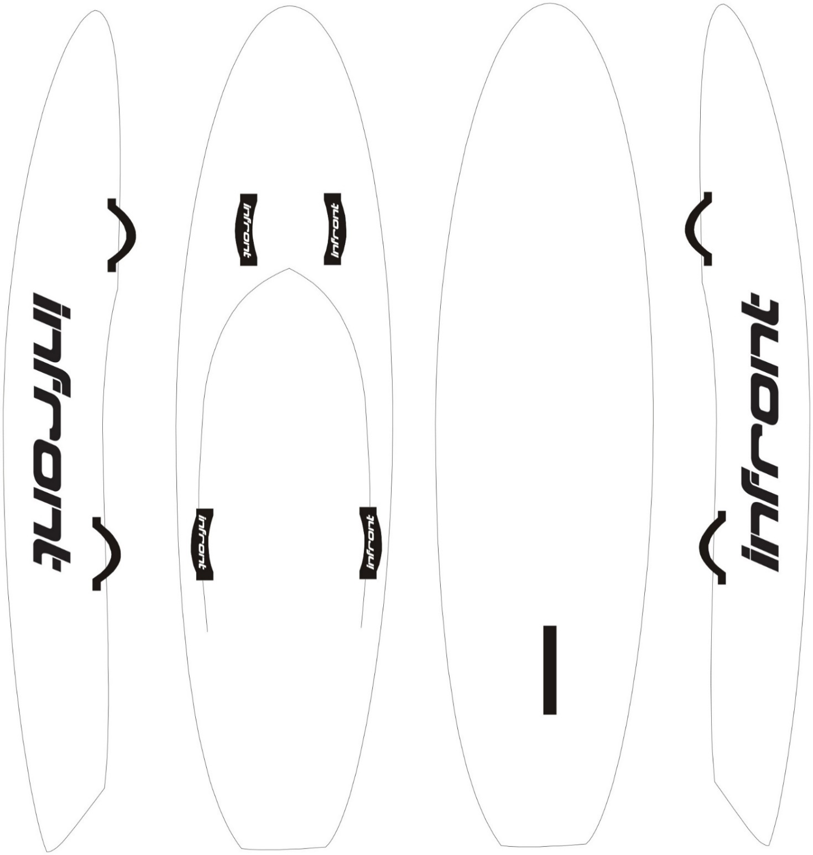

|  |
| --- |
| **NIPPER BOARD**  **DESIGN TEMPLATE** |

